**Installation Guide of SYNCHRO-NET simulator**

# 1. Installation

To run the project successfully, the prerequisite software:

1. MySQL

2. JDK

3. Java IDE Eclipse

4. R

5. Git

### 1.1 Download or clone the project from GitHub.

GitHub link: https://github.com/mercyforever/SynchroNet_simulator

### 1.2 MySQL

1) Install MySQL from official website. (MySQL workbench 6.3 is used in our development)

2) Set user (*root*) and password (*root*).

3) Create a database called ‘synchronet’.

4) Import SQLs into the database. ‘Database SynchroNET’ demonstrates the overall structure of the database.

### 1.3 JDK

Install JDK 1.8

### 1.4 Eclipse

1) Install Eclipse IDE

2) Import the downloaded project as Existing Maven Project.

Follow the steps stated in 2.2.2.1 - “*Working with the Synchronet Planner.pdf*”

### 1.5 R

#### (1) Running in Windows environment:

Install R as stated <http://codophile.com/2015/04/15/how-to-integrate-r-with-java-using-rjava/>

Note: configure the paths as following (*adapt to your actual installation location*)

R_HOME：C:\Program Files\R\R-3.2.2  
  
RJAVA_HOME：C:\Program Files\R\R-3.2.2\library\rJava  
  
PATH：%R_HOME%\bin;%R_HOME%\bin\x64;%RJAVA_HOME%\jri\x64;

#### (2)Running in Linux environment:

Follow this [link](https://binfalse.de/2011/02/20/talking-r-through-java/)

# 2. Build and Run

### 2.1 Debug mode

In order to run OTP in Debug Mode, open the **Debug Configurations** window from the **Run** menu. Here, create a new configuration of the **Java Application** type. This can be done by selecting **Java Application** from the list and clicking the **New Launch Configuration** button. The configuration has to know which project to launch and which the "main" class of the project is. Hence in the **Main** tab, select the following data:

* Project: **otp**
* Main class: **org.opentripplanner.standalone.OTPMain**

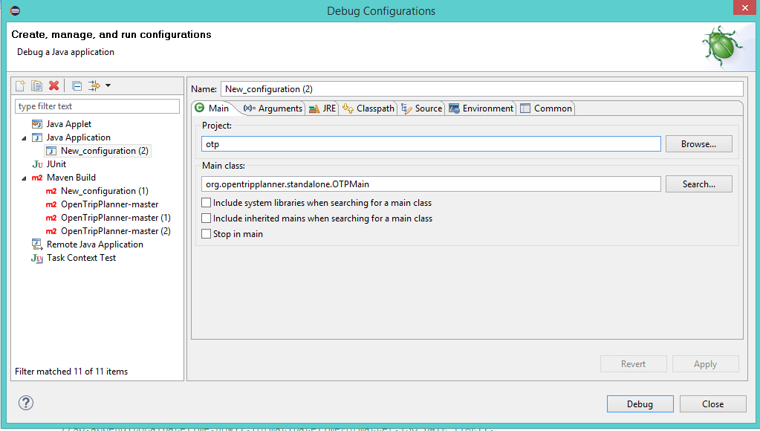

In order to launch the program with some particular parameters, these ones should be indicated in the **Arguments** tab.

There are two ways to launch the program.

#### Run with GTFS file

* Program arguments: **--build *data_path* --inMemory**
* VM arguments: **-Xmx8G**

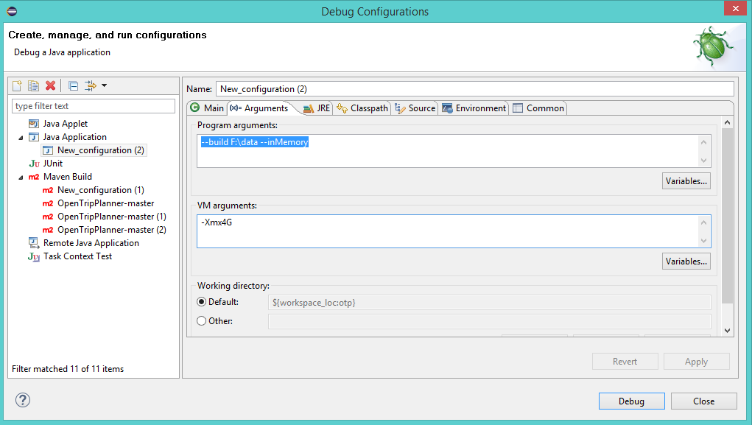

#### Run with graph object

1. Generate the graph object.

* Program arguments: **--build *data_path***
* VM arguments: **-Xmx8G**

2. Copy the generated graph.obj into YourPath\graphs\YourFolder (e.g. D:\SynchroNet\graphs\myGraph)

3. Launch the program with graph object.

* Program arguments: --router YourFolder **--basePath** YourPath **--inMemory**
* VM arguments: **-Xmx8G**

The software supports the multiple ‘–router’ parameters in order to load multiple graphs.

More details about the arguments is stated in 2.2.1 - “*Working with the Synchronet Planner.pdf*”.

### 2.2 GTFS format

* The simulator relies on the GTFS data. Please check 2.1.2 - “*Working with the Synchronet Planner.pdf*” for more information about general GTFS format.
* In SynchroNet project, we made several modification on the GTFS format. Please refer to “GTFS Structure”.
* We provide some examples of GTFS in the folder ‘Guide’.

### 2.3 GTFS editor

* The GTFS editor does not support multiple feeds in the current version.
* As shown below, use single GTFS feed and rename it as ‘privateGtfs.zip’. Keep all the GTFS files (contained in privateGtfs.zip) remaining in your folder.

